Testing & Evaluation
The quality assurance backbone of this project will consist of testing and evaluation. Testing and evaluation ensure that the system performs as expected and that the system operates securely and efficiently. As seen in the literature reviewed, working with financial data is considered high risk. Due to this sensitive nature, the testing aspect of the system is not just limited to the functionality aspect but also the workings of the data itself.
An iterative testing strategy was used, starting with unit tests at the development stage, advancing to integration testing as components were combined, and concluding with full end‑to‑end evaluations to validate the system’s overall performance and reliability. The main aims for this stage approach were to reduce defect propagation, support traceability, and ensure alignment with the set-out system requirements.
Primarily the Test After Development approach was used during the development of this project. Testing, such as unit tests were completed after the element of the system was developed. This practices still aligns with the iterative agile methodology this project closely follows. The idea of following the Test-Driven Development was considered, where the development process would be following the testing. This idea was eventually scrapped as TAD is a faster method that provided more flexibility in terms of some design changes in the project. (Understanding Test After Development in Unit Testing, no date).

Testing Objectives

Functional Correctness
The first focuses of the testing phase were aimed at validating the functional correctness of the systems core components. This included assessing the behaviour of the financial-document upload functionality, the NLP extraction pipeline, the NER module, the summarisation engine, and the anomaly-detection functionality. Each of these components was thoroughly examined to ensure that it produced accurate, reliable, and contextually meaningful outputs when applied to the uploaded financial documents. By confirming that these features performed as intended, the testing process established a solid foundation for the systems overall integrity.

Performance Requirements
In order to determine whether the system met the operational requirements defined, performance testing was conducted. This process involved evaluating the processing speed, responsiveness, and the efficiency of the summarisation and anomaly-detection stages under typical and high-load conditions. The aim of this section of the testing strategy was to gage whether the system could handle the realistic volumes of financial data without a drop in performance. This would support the projects overall aim for practical audits and compliance to the workflows.

Security and Privacy Requirements
Given the sensitive nature of financial documents, the system needed to be examined for its adherence to security and privacy requirements. This aspect of testing focused on how the uploaded documents were handled, how temporary data was managed, and whether the system-maintained safeguards for confidential and personally identifiable information. This section ensured that the system aligned with the best practices for secure data handling and respected the privacy constraints reviewed in the literature.

Usability and Accessibility
In order to ensure that the users could interact with the system effectively and intuitively, usability and accessibility was evaluated. This process involved assessing the interface clarity, the ease of document upload, and the interpretability of the outputs produced by the summarisation and anomaly-detection functionality. The accessibility functionality was also reviewed to confirm that the system could accommodate the requirements set out previously. These tests ensured that the system was technically robust enough to meet the project guidelines, while also being practical and user-friendly.

System Stability
The final section of the testing phase was examining how the system behaved under both expected and edge-case input conditions. This process included supplying the system with malformed, incomplete, or unusually formatted financial documents to observe how the system reacted. The aim here was to verify that the system was capable of handling such cases in a professional manner, without crashing or returning misleading results. This aspect of the testing confirmed that the system was resilient, and it had the ability to perform reliably in a real-world scenario.

Testing Methodology
As stated, testing was primarily conducted after the code had been written. The primarily aim of testing was to ensure reliability, performance, and the overall correctness of the system. The project implemented a multi-layer testing strategy that followed the Test After Development methodology. This process covered the frontend component behaviour, backend API logic, and evaluation of the NLP rules implemented in the pipeline.
Multilayer testing is aimed at implementing a well-structured approach to software development which will guarantee all levels of functionality. Layered testing has proved to lead to significant cost savings in real world applications, as any bugs would be spotted and fixed before final deployment. (Cannon, 2018).
The testing approach was divided into three primary layers:
- Frontend component testing
- Backend API, unit, and integration testing
- NLP rule evaluation through ablation testing
Each of these layers focused on validating different sections of the system while also ensuring that the overall application functions as an integrated platform.

Frontend Component Testing
Jest and React Testing Library was used to test the frontend section of the system. These were used to validate the behaviour of key parts of the user interface components. These tests covered key user interactions such as authentication and documentation upload, performed as expected and provided the user with appropriate feedback. The core components tested for this section was:
- Login component
- Registration component
- Document upload component

Login Component
The login component of the system was tested to verify successful login and submissions. Should either of these fail, the system would provide the user with error feedback. As the figure below shows the test functionality was passed, confirming that the user can sign in and see clear feedback should a failure occur.
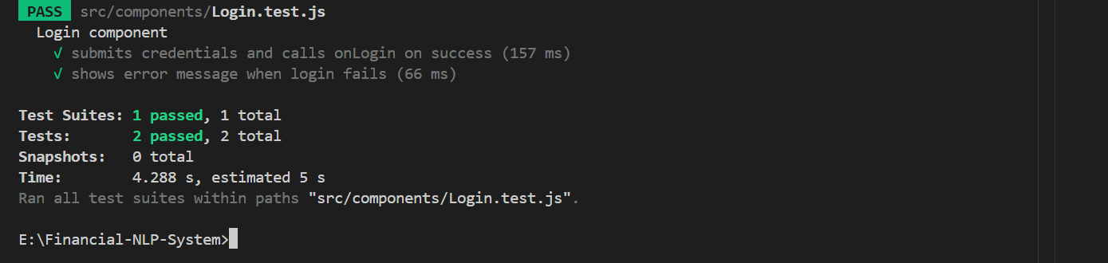
Figure 24 Login Test
As seen in the figure below, the core functionality of this test uses React Testing Library to fill in the user detail section of the Login field. Jest then intercepts the fetch call so that the tests control the API response. The test checks that a token and user object is returned , which shows that the onLogin functionality works as expected. Should this fail, then the user would be shown an appropriate error message.
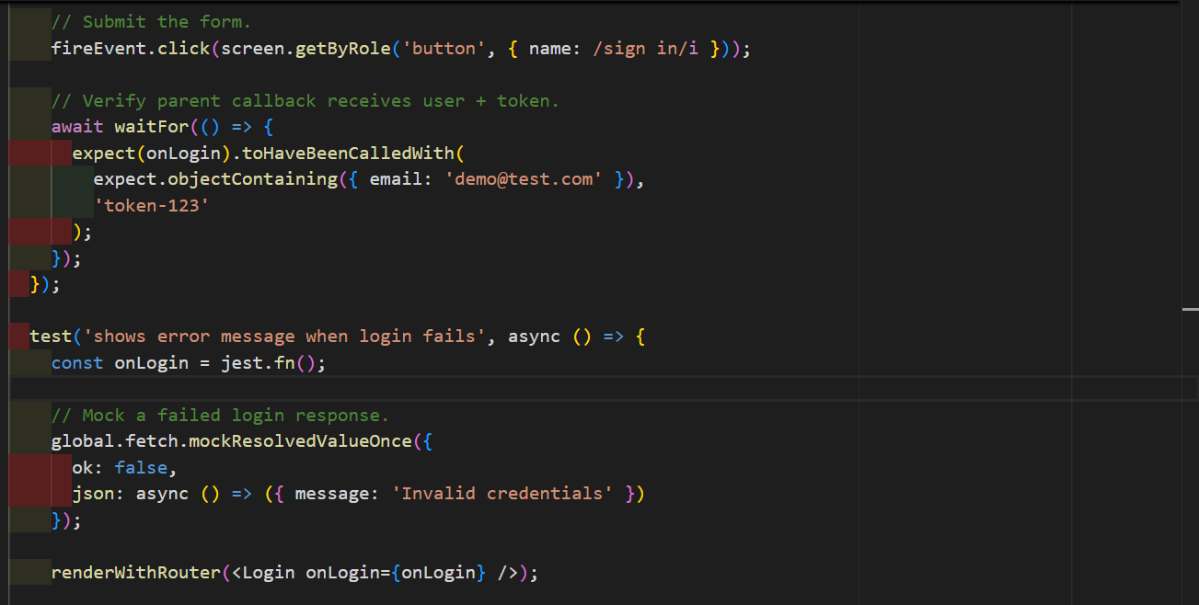
Figure 25 Login Test Functionality

Registration Component
The Registration Component validates the password rules and ensures that the registration component is correctly handled. This component ensures that weak passwords are flagged and prevented and it also verifies the registration flow. As seen in the code listing below, the testing functionality enters weak credentials to the input fields. The system would then flag these and return a password warning message to the user. Secondly the component would do the reverse of this, where a strong password would be entered and tested.

// Enter weak password to trigger client-side validation.
fireEvent.change(screen.getByLabelText(/username/i), { target: { value: 'newuser' } });
fireEvent.change(screen.getByLabelText(/email address/i), { target: { value: 'new@test.com' } });
fireEvent.change(screen.getByLabelText(/^password$/i), { target: { value: 'weak' } });
fireEvent.change(screen.getByLabelText(/confirm password/i), { target: { value: 'weak' } });

fireEvent.click(screen.getByRole('button', { name: /create account/i }));
// At least one password rule error should be shown.
expect(await screen.findByText(/at least 8 characters long/i)).toBeInTheDocument();
expect(onLogin).not.toHaveBeenCalled();
expect(global.fetch).not.toHaveBeenCalled();
});

test('registers successfully and calls onLogin', async () => {
const onLogin = jest.fn();

global.fetch.mockResolvedValueOnce({
ok: true,
json: async () => ({
token: 'register-token',
user: { id: 2, username: 'newuser', email: 'new@test.com', role: 'user' }
})
});
renderWithRouter(<Register onLogin={onLogin} />);

fireEvent.change(screen.getByLabelText(/username/i), { target: { value: 'newuser' } });
fireEvent.change(screen.getByLabelText(/email address/i), { target: { value: 'new@test.com' } });
fireEvent.change(screen.getByLabelText(/^password$/i), { target: { value: 'Strong@123' } });
fireEvent.change(screen.getByLabelText(/confirm password/i), { target: { value: 'Strong@123' } });
fireEvent.click(screen.getByRole('button', { name: /create account/i }));
await waitFor(() => {
expect(onLogin).toHaveBeenCalledWith(
expect.objectContaining({ email: 'new@test.com' }),
'register-token'

Code Listing 5 Registration Test

Upload Document Component
As seen in the Figure below, the Upload Document component passed the test guidelines. The test verifies the behaviour of the React component by mimicking its Hook so that the test can focus on the UI logic. The first of section checks whether the “Upload Document” button remains disabled when the no file is selected. This ensures that the user cannot submit an empty form. The second part of this section confirms that the upload function works as expected when the upload button is clicked. Combined these ensure that the component enables or disables the upload button depending on the state and trigger the upload action when appropriate. 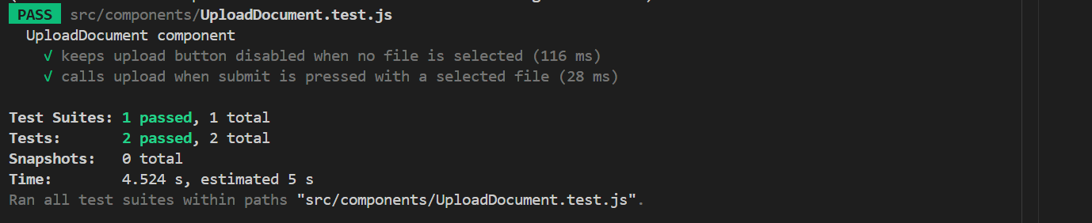
Figure 26 Upload Document Test Results

Backend API and Integration Testing
In order to validate the API endpoints, authentication logic, and database interactions in the backend section of the system, Jest and Supertest was implemented. These test cases focused on ensuring that the server-side logic functionality functions as expected and that the security features were correctly implemented.
The backend tests cover several of the critical areas of the system, including:
- Authentication and account management
- Role-based access control
- Document upload, storage, and deletion
- Financial risk classification rules
- End-to-end API workflows
Integration testing was also used to simulate the user experience, such as registering an account or logging in. These tests aimed to ensure that the various system components interacted with each other correctly when used together.

Authentication and Account Management
As seen in the Figure Listing below, this phase of testing established the register/login success and rejection paths. Its overall aim was to protect the core authentication functionality and ensure account security behaviour functionality. The Figure below shows the results of the test failing, indicating that registration was unsuccessful.
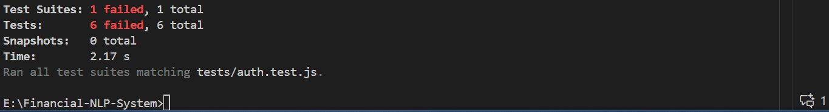
Figure 27 Authentication Test Results
The Code Listing below shows some of the functionality behind this test case. If, for example, the user has a weak password, the system would run the user’s password against its rule set. Either the password would be accepted as secure, or as the test case below shows it would be flagged and an error message returned to the user.
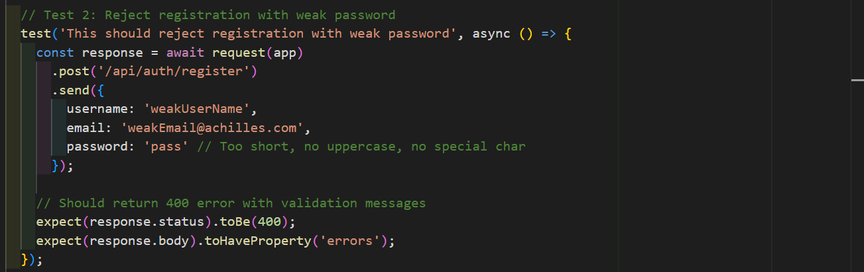
Figure 28 Registration Functionality - Password

User Management Test
This aspect of the testing phase validates role-based access control within the system. It ensures that regular users do not have the same permissions as the administrator. The admin has the ability to view or delete every aspect of a user’s profile. Verifying these permissions ensures that the security features are enforced and prevents unauthorized access to administrative features. The Code Listing below highlights some of the areas in which this test case was implemented. The functionality proved that regular system users do not process the same credentials as an administrator within the system.

// Test 2: Regular user cannot get all users
test('Regular user should NOT be able to get all users', async () => {
const response = await request(app)
.get('/api/users')
.set('Authorization', `Bearer ${regularUserToken}`); // Send regular user token
// Should be denied with 403 Forbidden
expect(response.status).toBe(403);
expect(response.body.message).toContain('Admin only');
});
// Test 3: Unauthenticated request should be denied
test('Should deny access without authentication token', async () => {
const response = await request(app)
.get('/api/users');
// No Authorization header
// Should return 401 Unauthorized
expect(response.status).toBe(401);
});
// Test 5: Regular user cannot delete users
test('Regular user should NOT be able to delete users', async () => {
// Create another user to try deleting
const testUser = await User.create({
username: 'todelete',
email: 'delete@test.com',
password: 'Test@123',
role: 'user'
});
const response = await request(app)
.delete(`/api/users/${testUser.id}`)
.set('Authorization', `Bearer ${regularUserToken}`);
// Should be denied
expect(response.status).toBe(403);
// User should still exist
const stillExists = await User.findByPk(testUser.id);
expect(stillExists).not.toBeNull();
});

Code Listing 6 User Management Test

Document Management Test
The Document Management testing focused on validating the lifecycle of a financial document within the system. It also played a part in verifying that the file security features were enforced, such as restricting uploads to a set file size. These features ensured that the system can mange uploaded documents safely while also protecting against invalid or unsafe files. The Code Listing below demonstrates the key functionality of this test. The test creates a “fake PDF” file type which should be caught by the test and be blocked from upload. Should a non-PDF file try being uploaded to the system, a 500 file-type validation error will be triggered, alerting the user that the system does not accept such file types. As seen in the Figure below, the full testing file for this section checked each of the mention functions.
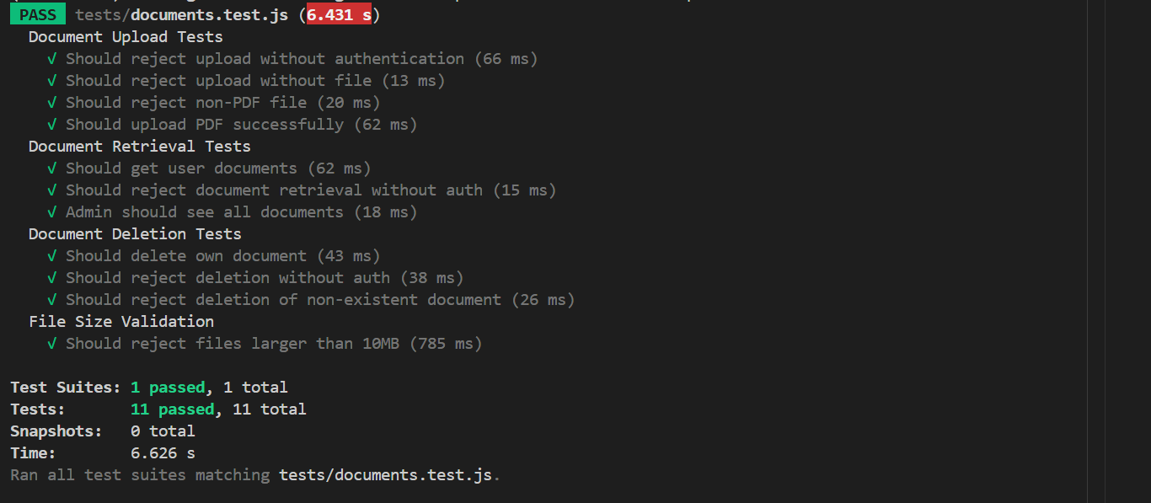
Figure 29 Document Management Test Results

describe('Document Upload Tests', () => {
test('Should reject upload without authentication', async () => {
const response = await request(app)
.post('/api/documents/upload')
.attach('document', Buffer.from('fake pdf content'), 'test.pdf');
expect(response.status).toBe(401);
expect(response.body.message).toContain('authentication');
});
// This test checks that the server validates the presence of a file. Even with valid authentication, the request should fail if no file is attached.
test('Should reject upload without file', async () => {
const response = await request(app)
.post('/api/documents/upload')
.set('Authorization', `Bearer ${testToken}`);
expect(response.status).toBe(400);
expect(response.body.error).toContain('No file uploaded');
});
// This test verifies that only PDF files are accepted. It uploads a .txt file and expects the server to reject it. 500 statue = file-type error
test('Should reject non-PDF file', async () => {
const response = await request(app)
.post('/api/documents/upload')
.set('Authorization', `Bearer ${testToken}`)
.attach('document', Buffer.from('not a pdf'), 'test.txt');
expect(response.status).toBe(500);
});
// This test checks the happy path: a valid PDF upload with authentication.
// It uses a simple buffer that *resembles* a PDF header (`%PDF-1.4`)—
test('Should upload PDF successfully', async () => {
// Create a minimal PDF-like buffer for testing purposes.
const pdfBuffer = Buffer.from('%PDF-1.4 fake pdf content');
const response = await request(app)
.post('/api/documents/upload')
.set('Authorization', `Bearer ${testToken}`)
.set('Content-Type', 'multipart/form-data')
.attach('document', pdfBuffer, {
filename: 'test-report.pdf',
contentType: 'application/pdf'

Code Listing 7 Document Management Test

Financial Risk Classification Test
As the auditing functionality was a key aspect of the project, it was essential to test the systems ability to actually perform the tasks. This test case evaluated the RAG classification system based on specific rule outputs. The test ensured that these classifications were implemented correctly when analysing the financial text. The test operates on the same basis as the actual auditing system, which has been covered in the implementation section of this report. The Figure below shows the output of the test file, where all tests have passed.
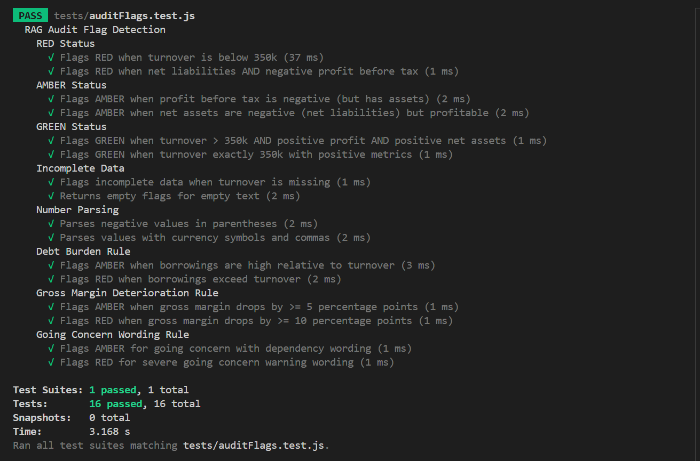
Figure 30 Audit Flag Test Report

Name Entity Recognition Accuracy Test
The NER accuracy was tested to evaluate the performance of the system’s ability to extract financial entities from the uploaded documents. The test measured the accuracy of the by implementing a standard evaluation metric, including precision, recall, and F1 score. These allowed the for the overall effectiveness of the NLP pipeline to be measured and monitored. The test, as shown in the Figure below, contained a collection of ground truths. These demonstrated the coverage across various document styles and entity types for the test to run off.
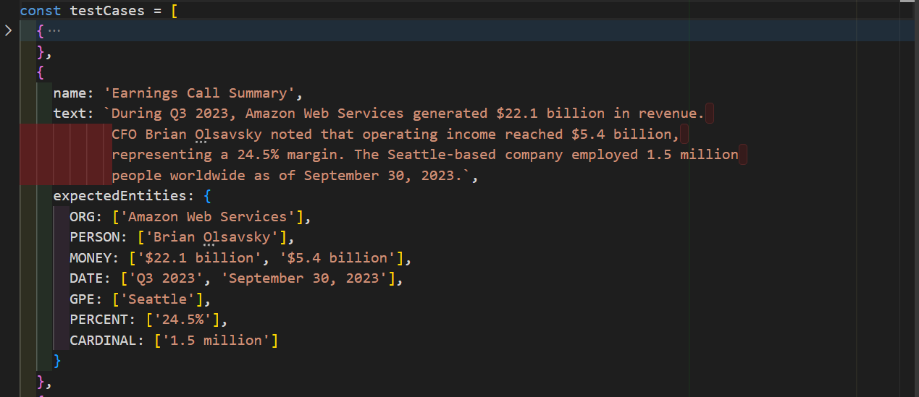
Figure 31 Ground Truths snippet
These were then tested against the core scoring logic, as seen in the Code Listing below. This section explained how the matching was completed and how the metrics were computed from true positives.

/**
* Normalize entity text for comparison (lowercase, trim whitespace)
*/
function normalizeEntity(text) {
return text.toLowerCase().trim().replace(/\s+/g, ' ');
}
/**
* Calculate precision, recall, and F1 score
* @param {Set} extracted - Set of extracted entity texts
* @param {Set} expected - Set of expected entity texts
* @returns {Object} - { precision, recall, f1 }
*/
function calculateMetrics(extracted, expected) {
// Normalize both sets so matching is case-insensitive and whitespace-safe.
const extractedNorm = new Set([...extracted].map(normalizeEntity));
const expectedNorm = new Set([...expected].map(normalizeEntity));
// True positives: entities that were both extracted and expected
let truePositives = 0;
for (const entity of extractedNorm) {
if (expectedNorm.has(entity)) {
truePositives++;
}
}
// Precision: TP / (TP + FP) = TP / extracted count
const precision = extractedNorm.size > 0 ? truePositives / extractedNorm.size : 0;

// Recall: TP / (TP + FN) = TP / expected count
const recall = expectedNorm.size > 0 ? truePositives / expectedNorm.size : 0;

// F1 Score: harmonic mean of precision and recall
const f1 = (precision + recall) > 0
? (2 * precision * recall) / (precision + recall)
: 0;

return {
precision: Math.round(precision * 100) / 100,
recall: Math.round(recall * 100) / 100,
f1: Math.round(f1 * 100) / 100,
truePositives,
extractedCount: extractedNorm.size,
expectedCount: expectedNorm.size
};
}

Code Listing 8 Accuracy Calculation Functions Test
Following this the test component then implemented the service integration and extraction pipeline. This section of the test documented the API evaluation path. This is particularly important for reproducibility. A section of this can be seen in the Figure below where the NER service is being called.
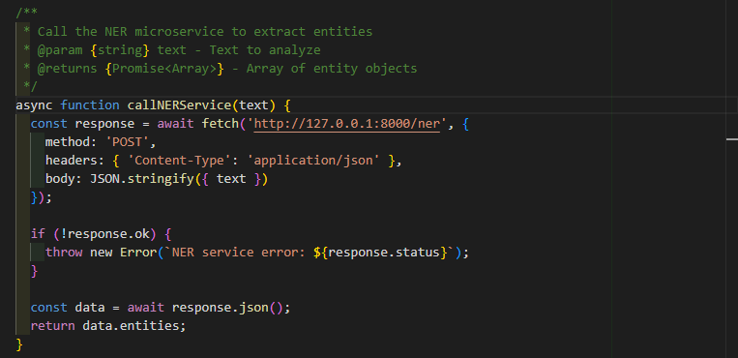
Figure 32 Service and Extraction Test
Finally, the per-document evaluation workflow and threshold assertion was completed. This was the most important aspect of the test as it showed:
- Per-type metric calculation
- Global Document scoring
- Structured logging for the found vs the expected
- Minimum recall gate (>=0.3)
A section of this test can be seen in the Figure below. The component calls the NER service to test the sample document against the parameters of the test as a whole.
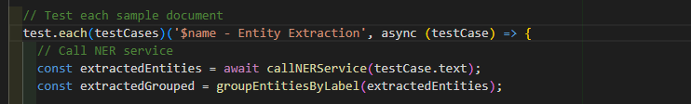
Figure 33 NER Sample Test

Summarisation and Explainability Test
This aspect of the testing component validated the summarisation and explanation features of the NLP pipeline. The generate summaries were checked to ensure they meet the requirements set out and that the decision traces included the correct amount of information for the audits. The primary aim of this component was to ensure the system remains transparent and interpretable. As seen in the Figure below the test suite passed.
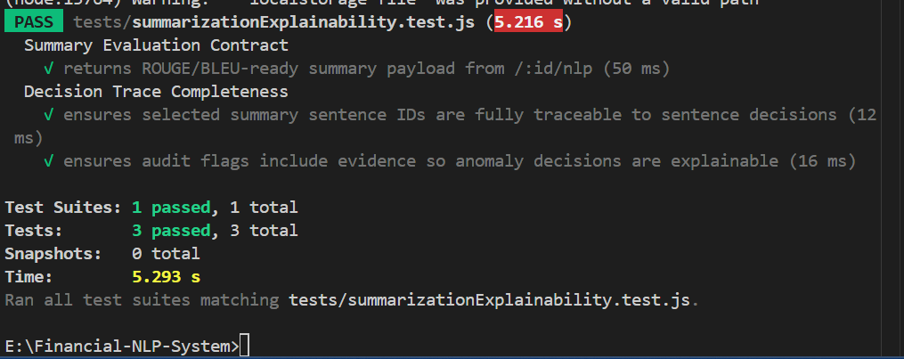
Figure 34 Summarization Test
It is in this section where the ROUGE and BLEU metrics are also tested, as seen in the Figure below.
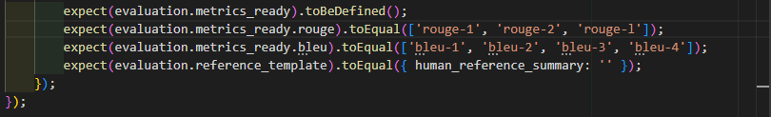
Figure 35 Summarization with ROUGE and BLEU
These metrics will be discussed further on in this report.

NLP Failure Handling Test
As the external Python NLP microservice was such a key part of the system, it was important to understand what would happen should this fail. This test case simulates that exact scenario. It verifies that the backend section of the system can handle a failure like this and produce safe fallbacks rather than causing the system to crash. This test case improves the overall reliability of the project.
As seen in the Figure below the test case acted as expected and passed the tests, showing that the system is robust enough to handle a component failure.
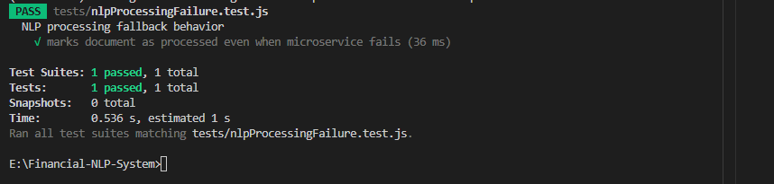
Figure 36 NLP Processing Fail Test
As seen in the Figure below, the test case created a mock base for both the NLP processor and the microservice.
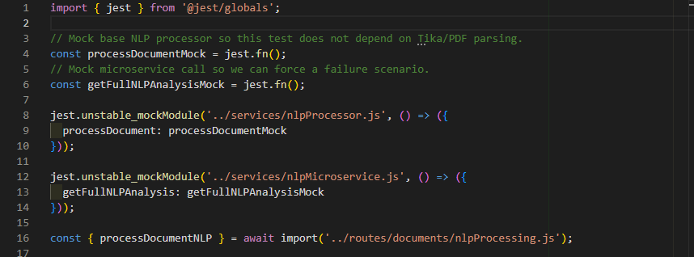
Figure 37 NLP Processing Failure Mock Cases
This make it so that the test isn’t relying on the Tika/parsing, like the actual system would be. The test allows the basic processor to succeed with the core NLP data but fails the microservice with a timeout. This can be seen demonstrated in the Figure below.
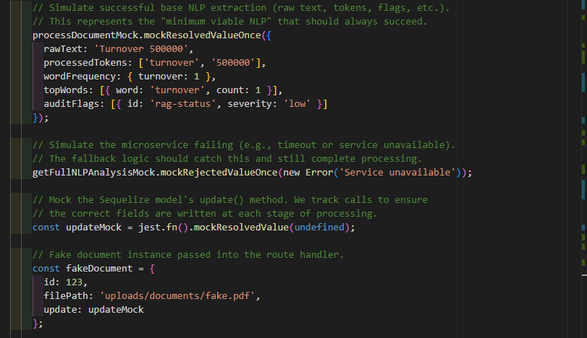
Figure 38 NLP Processing Failure Simulate Success
Following this, when the Python NLP microservice fails, the test will validate the document uploaded. This will bypass the errors, allowing the processing to start. The document will be marked as fully processed and the processor outputs will still be saved for user examination at a later stage. This can be seen demonstrated in the Figure below.
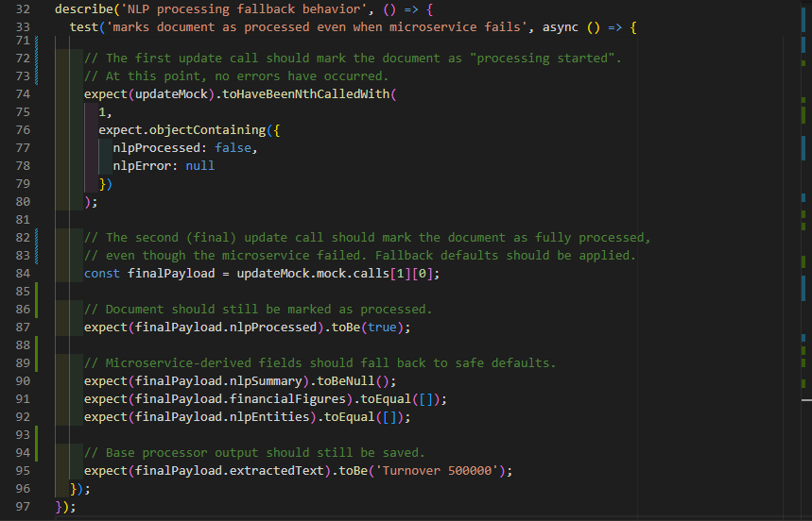
Figure 39 NLP Processing Failure Degrade Gracefully
This test case demonstrates the system’s ability to degrade gracefully should the Python NP microservice fail. While that section failing would not be ideal, it was beneficial to show that the system was resilient enough to handle such an event, rather than crashing outright. (Graceful degradation - Glossary | MDN, 2025).

End-to-End Smoke Test
An end-to-end smoke test is a testing methodology which validated the entire project workflow from the start to the end. It focuses on testing that the integrated components work together smoothly. (Powell and Smalley, 2025).
This aspect of the testing strategy performed a sequence of actions including:
- User Registration
- Login
- Document upload
- Document Listing
- Checking the NLP processing status
While these sections of the system were tested separately, it was important to validate that they could work together.
The test relied on mock instances of the key components of the system. It started with a clean slate, like a new user ready to access the system. It then simulated the steps a new user would take from logging in to document uploading as seen in the Figure below.
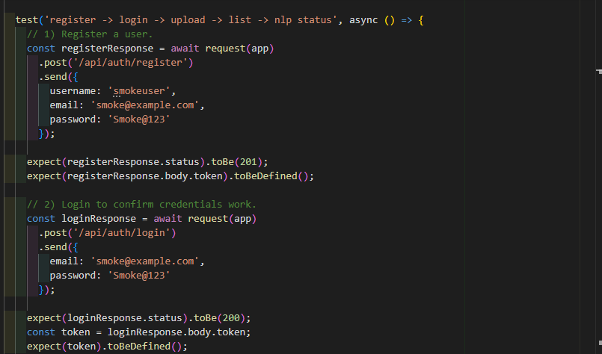
Figure 40 E2E Smoke Test P1
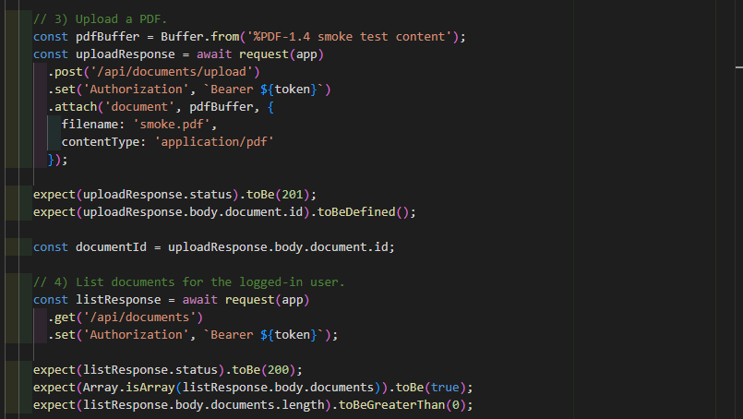
Figure 41 E2E Smoke Test P2
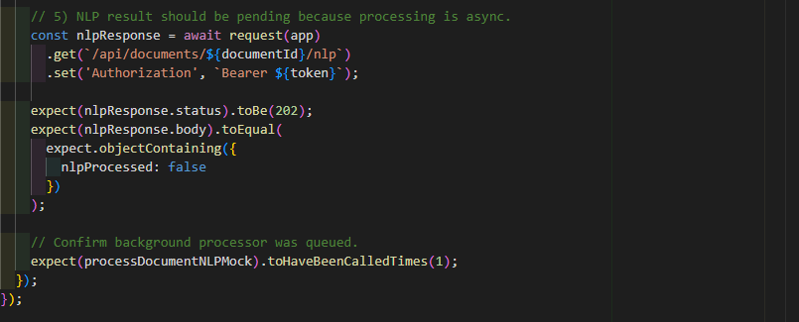
Figure 42 E2E Smoke Test P3
As seen in the Figure below the test case was able to confirm that each section of the system was able to work together as expected.
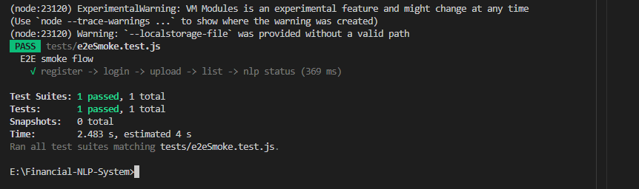
Figure 43 E2E Smoke Test P2

Ablation Study
An Ablation study is used to evaluate the contributions to the overall workings of the system. For the purposes of this project, it was implemented to measure how much each audit rule contributed to the detection quality.
The study works by implementing and running a fixed dataset of labelled financial test cases through the NLP pipeline. Each of these cases represents a financial document scenario which contain numerical values and financial statements. Each of the cases have a predefined expected output provided which include RAG risk classifications.
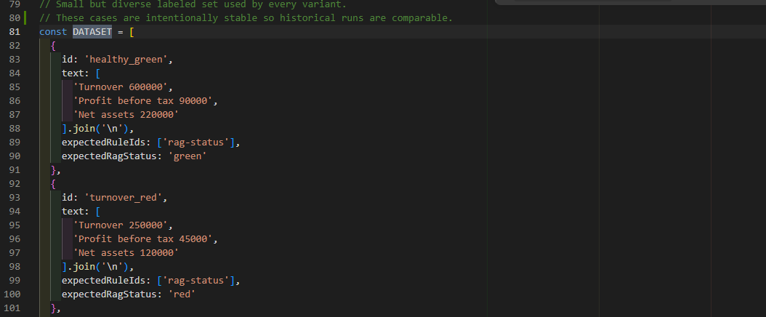
Figure 44 Ablation Study Dataset Example
The dataset is kept small but diverse, meaning that the risk scenarios can be evaluated. An example would be healthy financial statements.
The test then evaluates several of the rule variants, starting at the baseline configuration with all the rules enabled. New variants are then implemented by disabling certain rules in order to measure how the system behaves when the rules are removed. The audits rules which are analysed in the study was:
- RAG status classification
- Incomplete financial data detection
- Debt burden detection
- Gross margin deterioration detection
- Going concern risk detection
Each of these variants process the same dataset which produces a set of predicted rule flags.
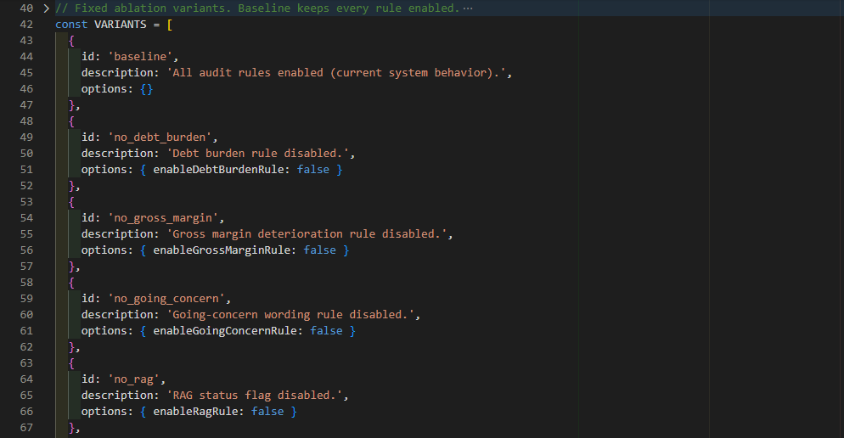
Figure 45 Ablation Study Variants
The outputs are then compared against the expected labels, making it possible to calculate evaluation metrics. The system is designed to measure precision, recall, and the F1 score. These quantify the accuracy of the rule predictions. The RAG classification is also calculated in order to measure its correctness in connection with the traffic-light system.
These metrics are then computed using the aggregated confusion counts, this includes the true positives, false positives, and the false negatives. These provide an understanding of how the system performs across the evaluated rules. This can be seen in the Figure below.
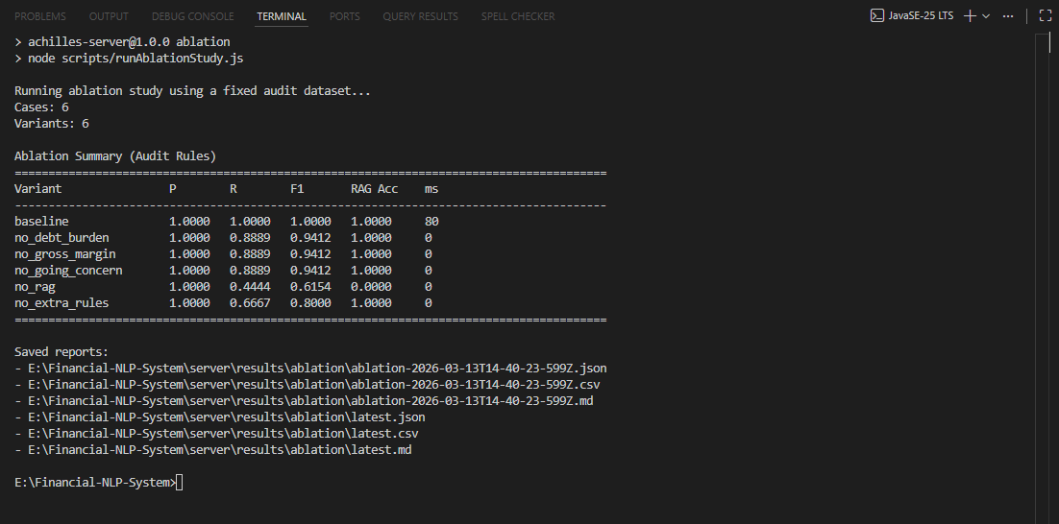
Figure 46 Ablation Study Results
The Ablation Study also was made to produce to structured reports which allow for the user to understand and further analysis the results. The study generates the output files in a structured directory within the file folders as seen in the Figure below.
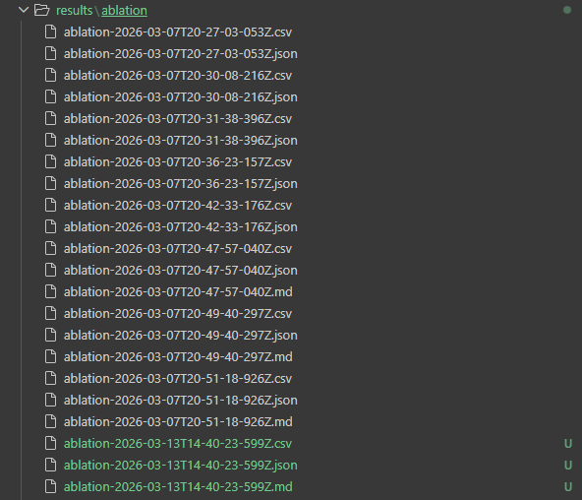
Figure 47 Ablation Study Result Files
The reports generated include:
- A JSON output which contains the detailed evaluation results for each of the variant rules.
- A CSV output which better displays the results in a spreadsheet format.
- A Markdown report that makes analysis more readable.
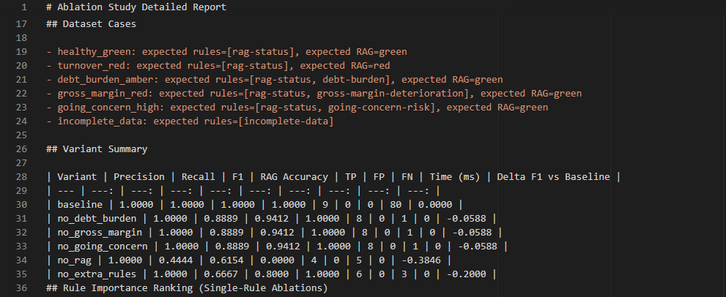
Figure 48 Ablation Markdown Snippet
The result of the study gives the user the ability to compare the results of the rule variant against the baseline configuration. This makes it possible to determine whether disabling a certain rule will cause a measurable reduction in the overall performance. If the performance did decrease, then this indicates that that rule is critical to the useful signal to the audit aspect of the pipeline.

Results/Evaluation Discussion

